**Ideation Phase**

**Brainstorm & Idea Prioritization Template**

|  |  |
| --- | --- |
| Date | 19 September 2022 |
| Team ID | PNT2022TMID15027 |
| Project Name | Hazardous Area Monitoring for Industrial Plant powered by IoT |
| Maximum Marks | 4 Marks |

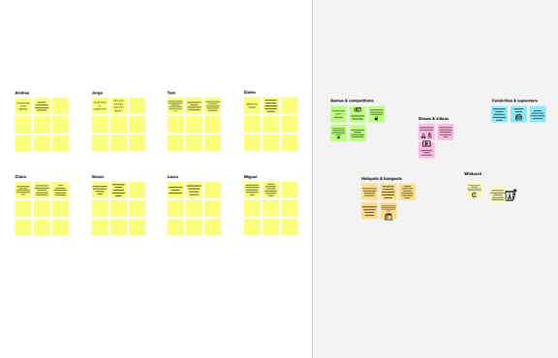

**Brainstorm**

**&ideaprioritization**

Use this template in your ownbrainstorming sessions so your teamcan unleash their imagination andstartshapingconceptsevenifyou'renotsittinginthesameroom.

**10minutes**toprepare

**1hour** to collaborate

**2-8people**recommended

**Sharetemplatefeedback**

**Needsomeinspiration?**

Seeafinishedversionof this template tokickstartyourwork.

**Openexample**

## Beforeyoucollaborate



Alittlebitofpreparationgoesalongwaywith this session. Here’s what you needtodotogetgoing.

**10minutes**

1. **Teamgathering**

Definewhoshouldparticipateinthesessionandsendaninvite.Sharerelevantinformationorpre-workahead.

1. **Setthegoal**

Think about the problem you'll be focusing on solving inthebrainstormingsession.

1. **Learnhowtousethefacilitationtools**

Use the Facilitation Superpowers to run a happy andproductivesession.

**Openarticle**

**1**

## Defineyourproblemstatement

What problem are you trying to solve? Frame yourproblemasaHowMightWestatement.Thiswillbethefocusofyourbrainstorm.

**5minutes**

**PROBLEM**

**How might we [yourproblemstatement]?**

**Keyrulesofbrainstorming**

Torunansmoothandproductivesession

Stay in topic.Deferjudgment.

Encourage wild ideas.Listentoothers.

Goforvolume. Ifpossible,bevisual.



**2**

## Brainstorm

**TIP**

You can select a sticky noteand hit the pencil [switch tosketch]icontostartdrawing!

Writedownanyideasthatcometomindthataddressyourproblemstatement.

**10minutes**

**Nerella Venkata Naga Anjeneya Sunil Sagar**

**Hazardous Area Monitoring it is a device which is useful for industrial plants**

**Pulimi Bhanu Prakash**

***This monitoring system is based on sensors***

**Effective time management As manual observation is time consuming**

**It may also cause lack of security**

**By monitoring we can improve productivity and quality**

**It improves efficiency**

**With this device risk reduces**

**cost effective**

# Kandra Yaswanth

**Karuvadi Phanindra Reddy**

**The hazardous area is any area with an atmosphere containing Gas leakages**

**The gases, vapors, dust which are flammable and explosive**

**Hygrometer is used to measure humidity levels**

**It is simple in construction and easy to use**

**Manual surveillance leading to health issues can be prevented**

**This device monitors temperature and humidity**

**It provide better security**

**We use python as software for recording data**

**3**



**Groupideas**

Taketurnssharingyourideaswhileclusteringsimilarorrelatednotesasyougo.Onceallsticky notes have been grouped, give each cluster a sentence-like label. If a cluster isbiggerthansixstickynotes,tryandseeifyouandbreakitupintosmallersub-groups.

**20minutes**

**TIP**

Addcustomizabletagstostickynotes to make it easier to find,browse, organize, andcategorize important ideas asthemeswithinyourmural.

**4**



**due to this monitoring we can improve productivity and quality**

## Prioritize

Yourteamshouldallbeonthesamepageaboutwhat'simportantmovingforward.Placeyourideasonthisgridtodeterminewhichideasareimportantandwhicharefeasible.

**20minutes**

**As manual observation is takes time consuming**

**Hygrometeris used to measure humidity levels**

**Hazardous Area Monitoring it is a device which is useful for industrial**

**It is simple in constructionand easy to use**

**this device monitors temperature and humidity**

**Importance**

**The hazardous area is any area with an atmosphere containing harmful gases**

If each of thesetasks could getdone without anydifficulty or cost,whichwouldhavethe most positiveimpact?

**TIP**

Participants can use theircursors to point at wheresticky notes should go onthegrid.Thefacilitatorcanconfirm the spot by usingthe laser pointer holding the**Hkey**onthekeyboard.

**this device monitors temperatureand humidity**

**Due this device it reduce risk**

**Feasibility**

Regardless of their importance, which tasks are morefeasiblethan others? (Cost, time, effort,complexity, etc.)

## Afteryoucollaborate



You can export the mural as an image or pdftosharewithmembersofyourcompanywhomightfindithelpful.

**Quickadd-ons**

1. **Sharethemural**

**Shareaviewlink**tothemuralwithstakeholderstokeepthemintheloopabouttheoutcomesofthesession.

1. **Exportthemural**

ExportacopyofthemuralasaPNGorPDFtoattachtoemails,includeinslides,orsaveinyourdrive.

**Keepmovingforward**

**Strategyblueprint**

Define the components of a new idea orstrategy.

**Openthetemplate**

**Customerexperiencejourneymap**

Understand customer needs, motivations, andobstaclesforanexperience.

**Openthetemplate**

**Strengths,weaknesses,opportunities&threats**

Identifystrengths,weaknesses,opportunities,andthreats(SWOT)todevelopaplan.

**Openthetemplate**

**Sharetemplatefeedback**